Comparative Analysis: Bubble Sort vs. Quick Sort

Sorting Algorithm Analysis: Bubble Sort vs. Quick Sort

Functionality
Bubble Sort is a comparison-based algorithm that repeatedly traverses a list, swapping adjacent elements that are out of order. Each pass "bubbles" the largest unsorted value to its correct position at the end of the array. While simple to implement, the standard version performs O(n²) comparisons regardless of the data's initial state unless optimized with a swap flag for early termination (which our benchmarks did not employ).

Efficiency: Small vs. Large Datasets
For small datasets (n < 50), Bubble Sort’s overhead is negligible. However, as n scales linearly, its performance experiences quadratic growth. In testing on a ThinkPad T490, sorting 100,000 integers took over 1,000 seconds. Conversely, Quick Sort; an efficient "divide and conquer" algorithm; achieves O(n log n) complexity by partitioning data around a pivot. At the same scale, Quick Sort outperforms Bubble Sort by several orders of magnitude, finishing the same 100,000 integer sort task in milliseconds.
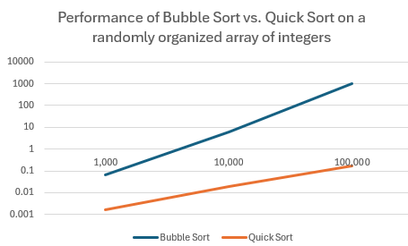
Figure 1 - scaling performance of Bubble Sort and Quick Sort over increasing workloads (logarithmic scale)

Hardware Anomalies and Real-World Use
An empirical anomaly was observed in our trails. Sorting a reverse-sorted list (theoretical worst-case for Bubble Sort) was faster than sorting random data. This is likely attributed to branch prediction (Hennessy & Patterson, 2017, p. 168). In a reverse list, the swap condition is consistently true, allowing the CPU to maintain a steady instruction prediction pipeline. Random data causes frequent "pipeline flushes" due to semi-frequent incorrectly predicted branches, increasing execution time despite fewer physical swaps.
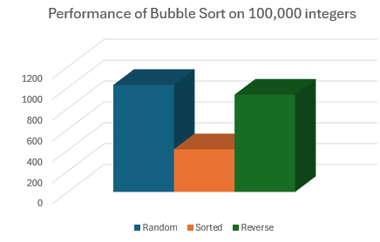
Figure 2 - Bubble Sort speed on random data outperforms a reverse-sorted array, likely due to brach chain optimization in the CPU.

Conclusion
Bubble Sort is rarely used in production due to its inefficiency at scale, appearing primarily in educational contexts or legacy systems where simplicity is paramount. Quick Sort and its derivatives remain the industry standard for high-performance systems, such as database indexing and SIEM log analysis, where O(n log n) scaling is a requirement for operational stability. Consequently, in order to provide sorted and reverse-sorted arrays in our trails, our Python script implemented Python’s native Timsort. While Timsort boasts the same O(n log n) efficiency as quick sort, it vastly outperformed our routine because it is implemented in a compiled C binary and therefore does not require a layer of interpretation. Further evidence that, while big-O notation can help us understand the theoretical scale of algorithms, real-world factors such as hardware optimization, are a huge factor in benchmarked performance test.

References
Cormen, T. H. et al. (2022) Introduction to Algorithms. 4th edn. Cambridge, MA: MIT Press.
Hennessy, J. L. and Patterson, D. A. (2017) Computer Architecture: A Quantitative Approach. 6th edn. Cambridge, MA: Morgan Kaufmann.

Appendix A: Benchmark Data
1000 | Random | Sorted | Reverse
Bubble | 0.06436 | 0.03447 | 0.07801
Insertion | 0.28444 | 0.00016 | 0.05812
Quick | 0.00172 | 0.0012 | 0.00113
Timsort | 0.00124 | 0.00001 | 0.00001

10000 | Random | Sorted | Reverse
Bubble | 6.08995 | 3.71938 | 8.67052
Insertion | 2.92352 | 0.00156 | 0.00156
Quick | 0.01941 | 0.01513 | 0.01513
Timsort | 0.00124 | 0.00009 | 0.00009

100000 | Random | Sorted | Reverse
Bubble | 1025.89544 | 408.83865 | 932.3487
Insertion | 321.67727 | 0.01734 | 650.7727
Quick | 0.17144 | 0.22103 | 0.22103
Timsort | 0.01632 | 0.00162 | 0.00162

Appendix B: Python Script
import time
import random
import sys

# 1. Bubble Sort
def bubble_sort(arr):
n = len(arr)
for i in range(n):
for j in range(0, n - i - 1):
if arr[j] > arr[j + 1]:
arr[j], arr[j + 1] = arr[j + 1], arr[j]
return arr

# 2. Quick Sort
def quick_sort(arr):
if len(arr) <= 1:
return arr
pivot = arr[len(arr) // 2]
left = [x for x in arr if x < pivot]
middle = [x for x in arr if x == pivot]
right = [x for x in arr if x > pivot]
return quick_sort(left) + middle + quick_sort(right)

# 3. Insertion Sort
def insertion_sort(arr):
for i in range(1, len(arr)):
key = arr[i]
j = i - 1
while j >= 0 and key < arr[j]:
arr[j + 1] = arr[j]
j -= 1
arr[j + 1] = key
return arr

# Setup Data
# Get data_size from CLI or default to 2000
try:
data_size = int(sys.argv[1]) if len(sys.argv) > 1 else 2000
except ValueError:
print("Error: Argument must be an integer. Defaulting to 2000.")
data_size = 2000

# Benchmark function
def benchmark(func, data, name):
start = time.perf_counter()
func(data.copy())
end = time.perf_counter()
print(f"{name:15}: {end - start:.5f} seconds")

# Dictionary of scenarios
scenarios = {
"Random": [random.randint(0, 10000) for _ in range(data_size)],
"Sorted": list(range(data_size)),
"Reverse": list(range(data_size, 0, -1))
}

for label, data in scenarios.items():
print(f"\nScenario: {label}")
print("-" * 30)
benchmark(bubble_sort, data, "Bubble Sort")
benchmark(insertion_sort, data, "Insertion Sort")
benchmark(quick_sort, data, "Quick Sort")
benchmark(sorted, data, "Python Timsort")

